**React JS**

**Episode 3:**

**Notes:**

React code formatter in vs code is Prettier

Npm run start or npm start

Npm run build

We can add scripts in package.json like below

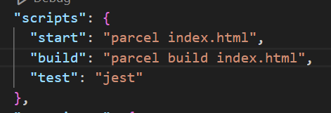

It works similar as “npx parcel index.html”

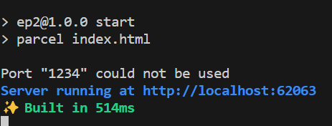

* Here after, we don’t use “react.createElement” . bcoz it looks very clumsy to us. To avoid this, we can use ‘JSX’ .
* JSX looks like HTML code. We can directly use JSX code inside react code
* JSX wont work in normal JS. But it is working fine in React code. This work done by Parcel [babel package]

**Babel: [transpiler]**

Convert JSX into react element

**React Components:**

2 types of components

1. Class based components
2. Functional components

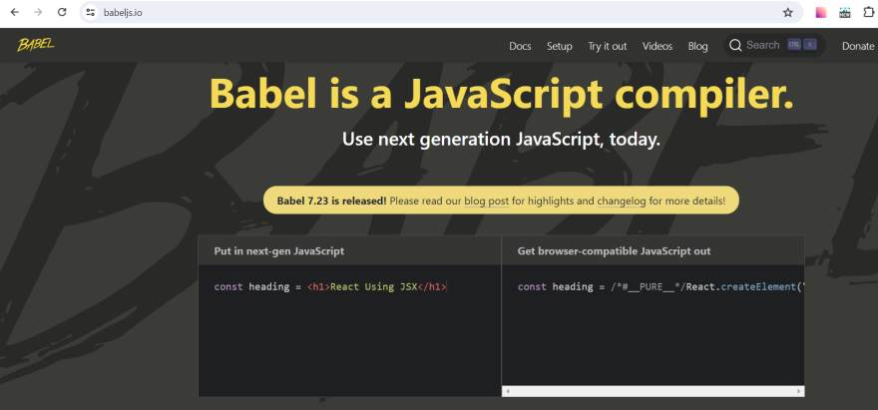

JSX differ with HTML

In HTML:

<h1 id=”heading” class=”root”>Namaste React</h1>

In JSX: [for attributes we are using camel case]

<h1 id=”heading” className=”root”>Namaste React</h1>

**Functional components:**

* It is normal js function and it returns jsx
* Component name start with capital letter like “Heading”

**Component composition:**

Composing 2 component in one another [add **Heading** component inside **Heading1** component]

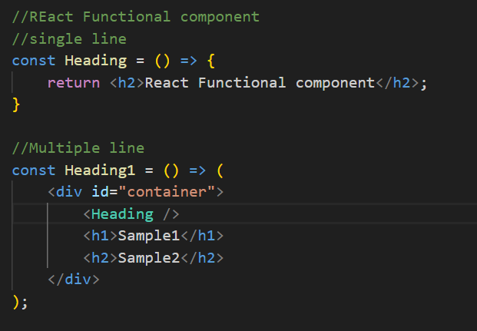

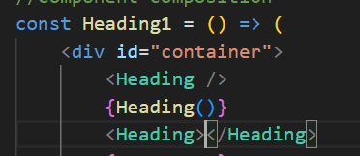

{} --> we can write any js code inside it in react functional component

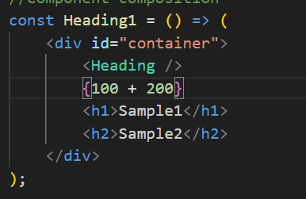

How to add react element inside react component --> by using {}

